Year 1 and 2 Suggested Artists
Cycle A
People | World Art | Landscapes
Norman Cornish  Local mining artist 1919-2014  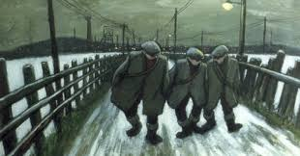 | Clementine Hunter  African American folk artist – 1887-1988  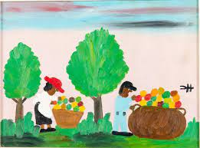 | Walter Holmes  Local landscape artist  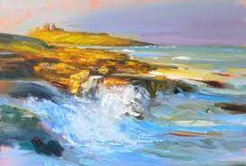
Toyin Ojin Odutola  Current female Nigerian portrait artist  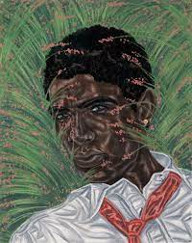 | Amrita Shir-Gil  Hungarian Indian painter 1913-1941  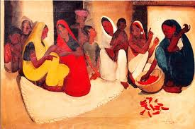 | Rebecca Vincent  Current local landscape artist  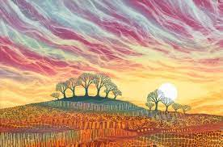
Andy Warhol (current)and Jean-Michael Basquiat (1960-1988)  Collaborated together  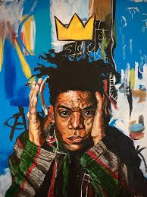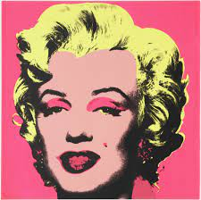 | https://insideafricanart.com/artists/  Various traditional African artists  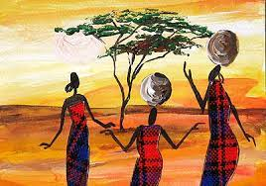 | LS Lowry (1887-1976) and other Northern Industrial Landscape artists  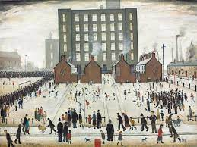

Cycle B
Landmarks | Fantasy Worlds | Natural World
Antony Gormley  Angel of the North  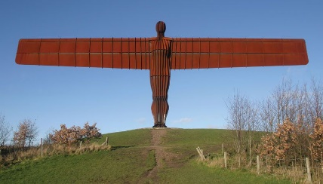 | Henri Rousseau  Book – Henri Rousseau’s Jungle Book  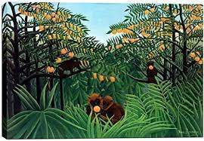 | Andy Goldsworthy  Richard Shilling  Chris Drury  Current British natural sculptors  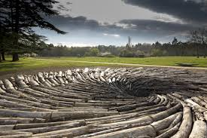
Keith Brownlie (architect)  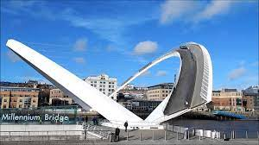 | Leonora Carrington  Female surrealist 1950’s  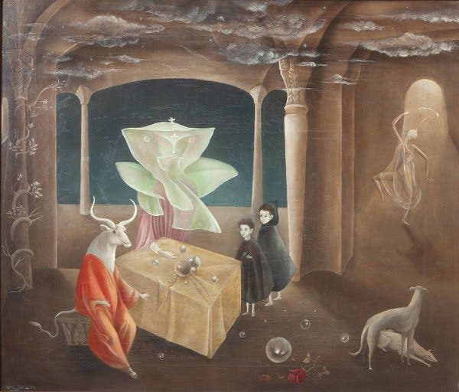 | William Morris  British textile designer 1834-1896  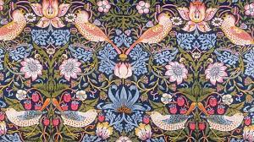
Tony Cragg  British born sculptor living in Germany  Turner prize winner  ‘Nerra Novalis’ - Consett Durham  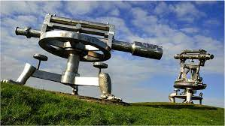 | Gustav Klimt  Austrian symbolist painter 1862-1918  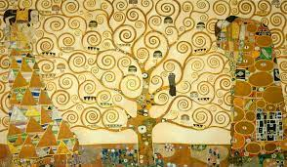 | Thomas Bewick  Local wood engraver 1753 – 1828  