Pupil premium strategy statement

Pupil premium is funding to improve education outcomes for disadvantaged pupils in schools in England. Evidence shows that disadvantaged children generally face additional challenges in reaching their potential at school and often do not perform as well as other pupils.

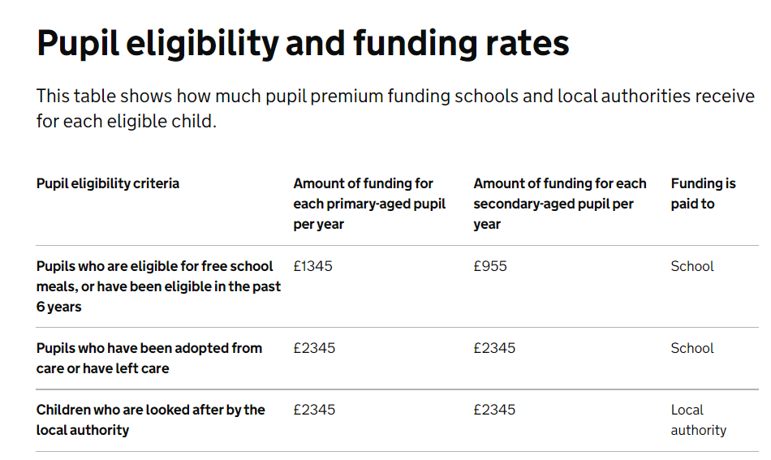

This statement details our school’s use of pupil premium (and recovery premium for the 2021 to 2022 academic year) funding to help improve the attainment of our disadvantaged pupils.

It outlines our pupil premium strategy, how we intend to spend the funding in this academic year and the effect that last year’s spending of pupil premium had within our school.

School overview
Detail | Data
School name | Newbrough CE Primary School
Number of pupils in school | 79
Proportion (%) of pupil premium eligible pupils | 10%
Academic year/years that our current pupil premium strategy plan covers (3 year plans are recommended) | 2021-2024
Date this statement was published | 1/12/21
Date on which it will be reviewed | 1/12/22
Statement authorised by | Jo Trotter
Pupil premium lead | Jo Trotter
Governor / Trustee lead | Jane Pybus
Funding overview
Detail | Amount
Pupil premium funding allocation this academic year | £10 760 +£4272 EYPP
Recovery premium funding allocation this academic year | £1167 (+£833 next)
Pupil premium funding carried forward from previous years (enter £0 if not applicable) | £0
Total budget for this academic year  If your school is an academy in a trust that pools this funding, state the amount available to your school this academic year | £16,199

Part A: Pupil premium strategy plan

Statement of intent
Our intention is that all pupils, irrespective of their background or the challenges they face, make good progress and achieve high attainment across all subject areas. The focus of our pupil premium strategy is to support disadvantaged pupils to achieve that goal, including progress for those who are already high attainers- and we recognise that there are a number of children currently receiving pupil premium who are in this group.
We need to consider the challenges faced by vulnerable pupils, such as those who have had a social worker in the past (none currently do) and those where parental support is not as focused as for some of our other children. An example of this would be of some of our older, higher attaining pupils who come from homes where access to books is limited and there are not good models of sustaining attention on reading or where households are busy and chaotic with several young children and pets.
We recognize that some of our youngest children have been impacted the most by repeated lockdowns and that this manifests itself in poor language, literacy and attention skills. We also know that children’s vocabulary skills can be linked to their economic backgrounds. By 3 years of age, there can be a 30 million word gap between children from the wealthiest and poorest families. The Oxford Language (2018) report ‘Why Closing the Word Gap Matters’ found that the word gap significantly impacts achievement. Teachers reported that pupils with low levels of vocabulary often:
Had difficulty working independently.
Had difficulty following what is going on in class.
Achieved worse results in national assessments.
Made slower than expected progress in English.
Made slower than expected progress in other subjects.
Even more significantly, Charlton and Asmussen (2017) found that children with language difficulties at age 5 were:
Four times more likely to have reading difficulties in adulthood.
Three times as likely to suffer from mental health problems.
Twice as likely to be unemployed in adulthood.
This picture is again backed up by the Oxford Language Report (2018), where teachers reported that pupils with lower levels of vocabulary were:
More likely to suffer from low self-esteem.
Less likely to stay in education and less likely to be able to find employment at the end of their school journey.
More likely to show negative behaviour.
More likely to have difficulty making friends.
More likely to have worse attendance.
The 2020 Oxford Language Report Bridging the Word Gap at Transition adds to this. It reports that 92% of teachers believe that the COVID-19 pandemic has widened the word gap, with 94% saying that they struggled to support pupils’ vocabulary development during remote learning.
High-quality teaching in small classes forms the core of our approach with additional, targeted support for some of our youngest children. This is proven to have the greatest impact on closing the disadvantage attainment gap and at the same time will benefit the non-disadvantaged pupils in our school. It is the intention that non-disadvantaged pupils’ attainment will be sustained and improved alongside progress for their disadvantaged peers. There is a focus across the school on the use of high-quality texts to support literacy teaching, with initiatives to raise the profile of books and reading and an insistence on a dedicated time for stories in each class.
As a small school, we know our children well and so our approach will be responsive to common challenges and individual needs, rooted in observation, discussion and robust diagnostic assessment where needed.
The approaches we have adopted complement each other to help pupils excel. To ensure they are effective we will:
- ensure disadvantaged pupils are challenged in the work that they’re set
- act early to intervene at the point need is identified
- adopt a whole school approach in which all staff take responsibility for disadvantaged pupils’ outcomes and raise expectations of what they can achieve

Challenges

This details the key challenges to achievement that we have identified among our disadvantaged pupils.
Challenge number | Detail of challenge
1 | Assessments and observations indicate underdeveloped listening and attention skills These are evident from Reception through to KS2 and, in general, are more prevalent among our disadvantaged pupils than their peers.
2 | Assessments, observations, and discussions with pupils indicate underdeveloped oral language skills and vocabulary gaps among many disadvantaged pupils. These are especially evident in Nursery and Reception and in general, are more prevalent among our disadvantaged pupils than their peers.
3 | Observations and discussions with pupils indicate a lack of access to stories/ rhymes/ books at home for some of our disadvantaged pupils. This, combined with points 1 and 2 above, can mean that learning to read is more of a challenge for our pupils. There can also be low parental confidence or lack of time for working parents in supporting pupils with their reading at home.
4 | Our assessments, observations and discussions with pupils and families have identified a lack of enrichment opportunities- especially during the pandemic. This is particularly true for our disadvantaged pupils, and can affect their attainment.
5 | Observations and discussions with pupils have indicated that pupils are unaware of the range of career options open to them which could lead to a lack of aspiration

Intended outcomes
This explains the outcomes we are aiming for by the end of our current strategy plan, and how we will measure whether they have been achieved.
Intended outcome | Success criteria
Improved oral language skills and vocabulary among disadvantaged pupils. | Assessments and observations indicate significantly improved oral language among disadvantaged pupils. This is evident when triangulated with other sources of evidence, including engagement in lessons, book scrutiny and ongoing formative assessment.
Improved reading attainment among disadvantaged pupils | KS 2 SATs show that 100% of disadvantaged children achieve at or above ARE in reading each year
Improved experience of a range of enrichment activities eg participation in PE/ sports; a range of extracurricular clubs and activities; educational visits and residential experiences; Mini Police | Residential visits take place in Y4/6.  90% PP children attend after school clubs and activities where offered; each class takes part in at least one educational visit per year.
By the end of KS 2, our disadvantaged children will have had the opportunity to visit a university or college or meet with Higher Education students and they will have had talks/ input from a range of professionals about their careers. | Apprentice student on campus opportunities taken up In Y5/6; 3 (minimum) visits per year from people in different careers/ professions

Activity in this academic year
This details how we intend to spend our pupil premium (and recovery premium funding) this academic year to address the challenges listed above.

Teaching (for example, CPD, recruitment and retention)
Budgeted cost: £ 5850
Activity | Evidence that supports this approach | Challenge number(s) addressed
Additional adult employed to support youngest children with language, stories and supporting within their play. | Oral language interventions can have a positive impact on pupils’ language skills. Approaches that focus on speaking, listening and a combination of the two show positive impacts on attainment:  Oral language interventions | EEF (educationendowmentfoundation.org.uk) | 1,2

Targeted academic support (for example, tutoring, one-to-one support structured interventions)
Budgeted cost: £ 4985
Activity | Evidence that supports this approach | Challenge number(s) addressed
Target children in Nursery receives small group language intervention | Oral language interventions can have a positive impact on pupils’ language skills. Approaches that focus on speaking, listening and a combination of the two show positive impacts on attainment:  Oral language interventions | EEF (educationendowmentfoundation.org.uk) | 1
Embedding dialogic activities across the school curriculum. These can support pupils to articulate key ideas, consolidate understanding and extend vocabulary.  We will purchase resources ( eg graphic novels, high level texts) and fund ongoing teacher training and release time plus maintain existing small classes with high level of TA support for small group work | There is a strong evidence base that suggests oral language interventions, including dialogic activities such as high-quality classroom discussion, are inexpensive to implement with high impacts on reading:  Oral language interventions | Toolkit Strand | Education Endowment Foundation | EEF | 1,2,3

Wider strategies (for example, related to attendance, behaviour, wellbeing)
Budgeted cost: £5,364
Activity | Evidence that supports this approach | Challenge number(s) addressed
Provision of free school meals. | Children have a healthy, balanced meal which enables them to focus on learning as they are not hungry.
Enrichment activities subsidised |  | 4
Contingency fund | Based on our experiences and those of similar schools to ours, we have identified a need to set a small amount of funding aside to respond quickly to needs that have not yet been identified eg uniform purchase; subsidised breakfast clubs

Total budgeted cost: £ 16, 199

Part B: Review of outcomes in the previous academic year

Pupil premium strategy outcomes
This details the impact that our pupil premium activity had on pupils in the 2020 to 2021 academic year.
Due to COVID-19, performance measures have not been published for 2020 to 2021, and 2020 to 2021 results will not be used to hold schools to account. Given this, please point to any other pupil evaluations undertaken during the 2020 to 2021 academic year, for example, standardised teacher administered tests or diagnostic assessments such as rubrics or scales.
If last year marked the end of a previous pupil premium strategy plan, what is your assessment of how successfully the intended outcomes of that plan were met?

