Year 3 and 4 Suggested Artists
Cycle A
People | World Art | Landscapes
Amy Sherald  Current African American portraitist  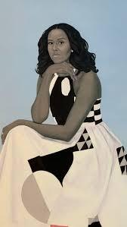 | Farwa Moledina  Current British Muslim  Pattern/textiles  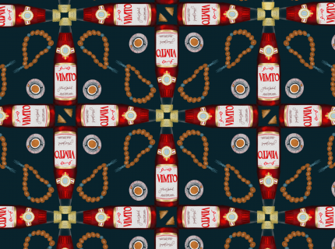 | Friedensreich Hundertwasser  Austrian landscape painter and architect  1928-2000  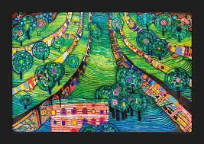
Li-Shan Chong  Singapore born British painter  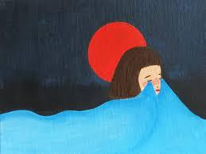 | Tamara Natalie Madden  Jamaican born African American painter  (could also be used for ‘People’ theme)  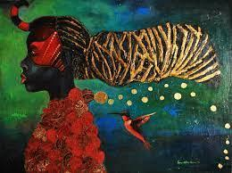 | Ruth Bond  Local landscape artist  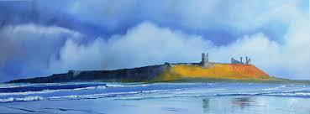
Giuseppe Arcimboldo  Italian painter 1527-1593  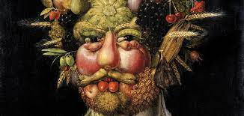 | https://www.aboriginal-art-australia.com/aboriginal-art-library/the-story-of-aboriginal-art/  Various aboriginal artists  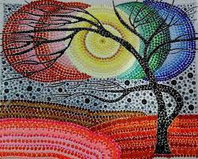 | Vincent Van Gogh  Dutch post impressionist painter 1853-1890  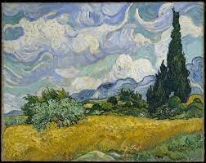

Cycle B
Landmarks | Fantasy Worlds | Natural World
Antoni Gaudi  Catalonian modernist architect 1852-1926  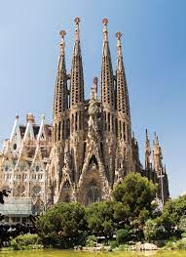 | Pauline Baynes  Original illustrator for ‘The Lion the Witch and the Wardrobe’  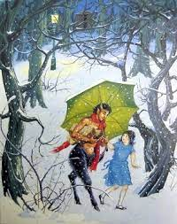 | Lindsey Cooper  Current local printmaker  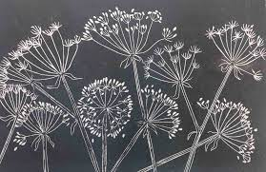
Simon Hitchens  Current British sculptor  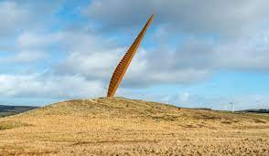 | Albrecht Durer  German painter and printmaker 1480’s  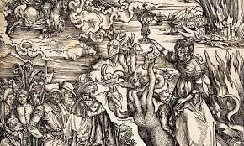 | Cathy Duncan  Current local printmaker - lino prints  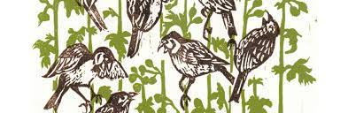
Charles Jencks  American landscape designer 1939-2019  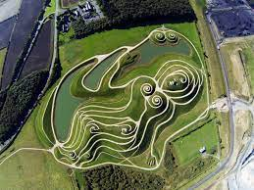 | Faith Ringgold  Painter, quilter, mixed media sculptor, performance artist and children’s author  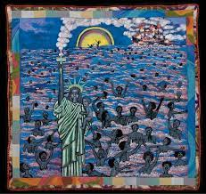 | Shelley Jayne  Current children’s book illustrator and printmaker  