Year 5 and 6 Suggested Artists
Cycle A
People | World Art | Landscapes
Antony Gormley  Sculpture of human figures  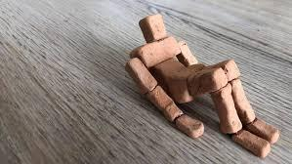 | Katsushika Hokusai  Japanese painter 1830’s  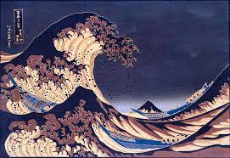 | Albert Namatjira  Aboriginal landscape artist 1902-1959  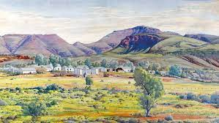
Frida Kahlo  Mexican painter  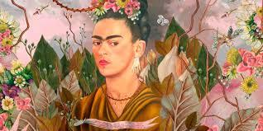 | Lois Mailon Jones  African American painter and illustrator 1905-1998  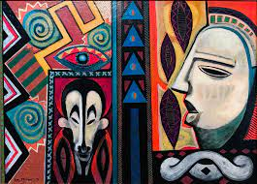 | James Hole  London born, based in Northumberland - Landscape photographer  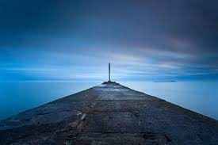
Henry Moore  British abstract sculptor 1898-1986  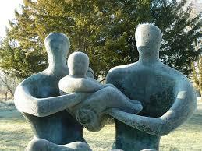 | Natalia Groncharova  Russian painter 1881-1962  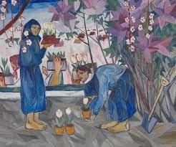 | Georgia O Keefe  American landscape artist (could also be used for natural world)  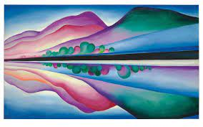

Cycle B
Landmarks | Fantasy Worlds | Natural World
Lindisfarne Gospels  Anglo Saxon English manuscript  (link to Lindisfarne castle/priory)  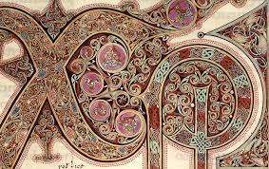 | Salvador Dali  Spanish surrealist icon 1904-1989  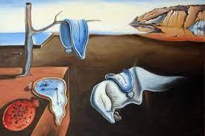 | Stewart Sexton  Current local painter of natural world - good for sketch book work  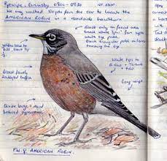
Richard Rogers  Millenium dome architect  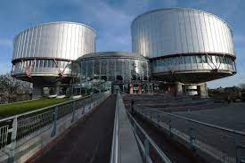 | Kara Walker  Current silhouettist, filmmaker and sculptor  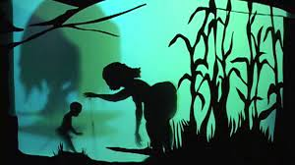 | Renira Barnes and Jane Murray  Current local natural world artists who have worked together  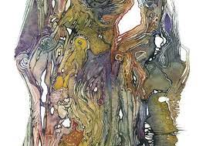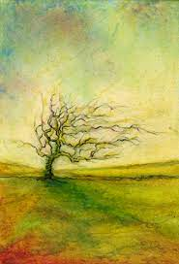
Norman Foster  Sage Gateshead, Gherkin London  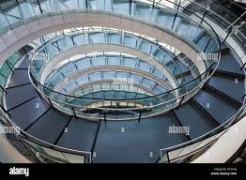 | Mary GrandPre  American illustrator for Harry Potter books  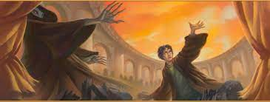 | Benjamin West  Use collage to combine nature and machines  