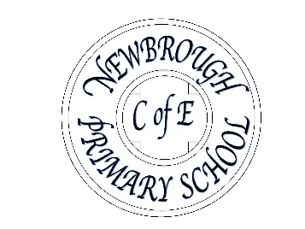
Early Years Foundation Stage.
Newbrough Church of England Primary School,
Fourstones, Hexham, Northumberland, NE47 5AQ.

Head teacher Mrs Jo Trotter

Telephone (01434) 674284
E-mail: admin@newbrough.northumberland.sch.uk
Website: www.newbroughprimaryschool.org.uk

Starting School – Useful information and frequently asked questions
.
What to expect, when?

A document which gives guidance about your child’s learning and development in the early years foundation stage can be found on-line at the link below
https://www.foundationyears.org.uk/files/2015/03/4Children_ParentsGuide_2015_WEB.pdf

What should my child be able to do before they start school?
You can really help your child make a smooth start at school by teaching them to do the following things independently.

- use the toilet independently
- wash and dry their hands
- take their shoes on and off independently
- take off and put on their coat and find the hook to be able to put it on their peg
- wipe/blow their nose
- use a knife and fork to feed themselves

Looking after belongings
Children are encouraged to look after their own belongings but inevitably, things can go astray. Label everything! If it can be picked up or put down, please ensure your child’s name is on it and it will most likely end up back where it belongs. Lost property is collected in a box in the nursery cloakroom.

Can my child access water or snacks?
Please provide water in a named water bottle. These are kept out for children to access when they want. They must contain water only – no juice and should be taken home daily to wash.

What should my child have at school?

We kindly ask that you use a drawstring PE bag that can hang underneath their coat and a school book bag rather than a rucksack as we have limited space. This should have in spare underwear and socks and in the winter, an extra layer and welly socks to ensure children are comfortable outside. Children should have a pair of wellies that they can leave at school and waterproofs. Book bags should be brought into school and are kept in a box in the cloakroom. Toys from home should not be brought into school.

What if my child has medicine to take?
Only prescribed medicines can be administered at school and should this situation arise, you need to fill out a form at school.

What if I need someone else to collect my child?
In the event that someone else is picking up your child from school, please ensure you inform school by either speaking directly to the teacher or ringing the office.

Where do I pick up and drop off?
Nursery children enter school through the EYFS door. It will really help your child to learn routines if you let them carry their own belongings and take off their coats when they come into school. Pick up at lunch time is at the KS1 side door. Pick up at the end of the school day is at the EYFS door. Reception children line up in the yard at 8.50. They are dismissed at the EYFS door at 3.10pm

