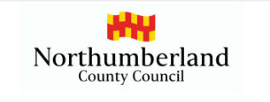
Dear Parent,
Under the requirements of s7 of the Education Act 1996 (“the 1996 Act”) it is the duty of a parent to ensure that every child of compulsory school age receives efficient full-time education suitable to their age, ability and aptitude and to any special educational needs or additional learning needs they may have.
New legislation comes into force on 19th August 2024 regarding the issue of Penalty Notices to address attendance concerns to commence, there will be a transitional period, but this new legislation will take effect for absences recorded from the start of the new academic year commencing in September 2024.
The following changes have been made:
- There will be a new “National Framework” which introduces consistency in the use of Penalty Notices across England by introducing a new national threshold at which they are considered. This will be met when a pupil has been recorded as absent for 10 sessions ( 5 school days) within a rolling period of 10 school weeks

- The National Framework also introduces a new national limit of 2 Penalty Notices within a 3-year rolling period.

- Penalty Notices can be requested by schools and academies and will be issued by the Local Authority to the parents/carers of statutory school age children, per parent, per child as appropriate.

- For a first offence, the Penalty Notice will be £80 per parent per child if paid within 21 days rising to £160 if paid after the 21 days – it must be paid within 28 days.

- For a second offence, the amount is £160 per parent per child to be paid within 28 days.

Please note that a third penalty notice cannot be issued to the same parent for the same child within three years of the date of issue of the first. Prosecution / other interventions will be considered.

Should a Penalty Notice remain unpaid and it is not withdrawn then a prosecution for the substantive offence of failing to secure the regular attendance of a child of compulsory school age at school will be considered.

Further information can be found at:
https://www.gov.uk/government/publications/working-together-to-improve-school-attendance
Email educationwelfare@northumberland.gov.uk
You can also ring/email your child’s school.
Yours sincerely,
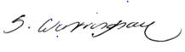
Sarah Wintringham – Principal Education Welfare Office

